# How to achieve a bearer token authentication and authorization in ASP.NET Core

## Introduction

ASP.NET Core is the new cross platform framework for web, there have some difference about token base authentication and authorization between .NET Core and Classic .NET Framework.

This sample will show you how to achieve a bearer token base authentication and authorization in ASP.NET Core.

## Sample prerequisites

* .NET Core 1.0 or later version(s). [[Visual Studio 2015 Home page installer](https://www.visualstudio.com/en-us/visual-studio-homepage-vs.aspx)]
* Microsoft Visula Studio 2015 update3 or above. [[.Net Core + Visual Studio tooling](http://go.microsoft.com/fwlink/?LinkID=798306)]

## Building the sample

* Open the sample solution “**CSTokenBaseAuth.sln**” using Visual Studio.
* Right click on project “” and select Restore packages.

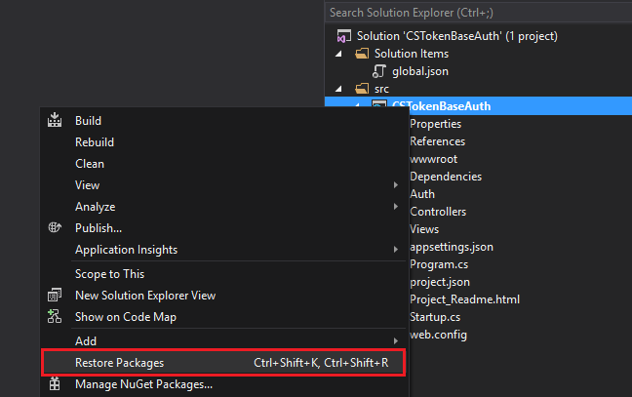

* Press **F6 Key** or select **Build -> Build Solution** from the menu to build the sample.

## Running the sample

* Open the sample solution using Visual Studio, then press **F5 Key** or select **Debug -> Start Debugging** from the menu.
* When application is running, you can see a blank page, go to address: <http://localhost:40260/Login/index> , you can see below UI.

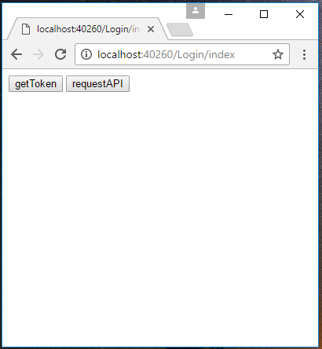

* Press Key F12 to open web page debug tool, and switch to “**Console**” tab.

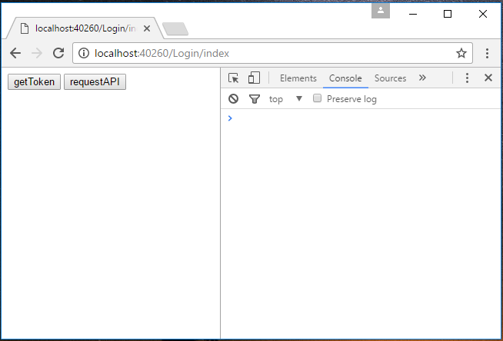

* Click button “**getToken**” and then javascript will send a request to get token, and save to local.

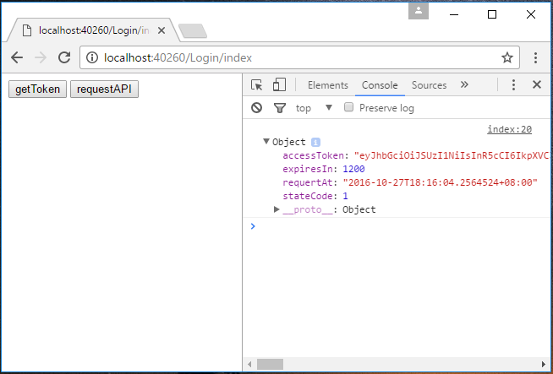

* Then click the “**requestAPI**” button. Javascript will visit an author page, and get data from server.

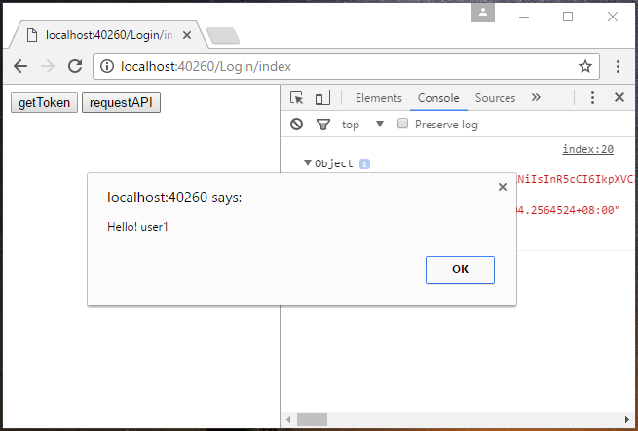

## Using the code

* **For authentication**

**TokenAuthController.cs**

[HttpPost]

public string GetAuthToken(User user)

{

var existUser = UserStorage.Users.FirstOrDefault(u => u.Username == user.Username && u.Password == user.Password);

if (existUser != null)

{

var requestAt = DateTime.Now;

var expiresIn = requestAt + TokenAuthOption.ExpiresSpan;

var token = GenerateToken(user, expiresIn);

return JsonConvert.SerializeObject(new {

stateCode = 1,

requertAt = requestAt,

expiresIn = TokenAuthOption.ExpiresSpan.TotalSeconds,

accessToken = token

});

}

else

{

return JsonConvert.SerializeObject(new { stateCode = -1, errors = "Username or password is invalid" });

}

}

private string GenerateToken(User user, DateTime expires)

{

var handler = new JwtSecurityTokenHandler();

ClaimsIdentity identity = new ClaimsIdentity(

new GenericIdentity(user.Username, "TokenAuth"),

new[] { new Claim("UserName", user.Username) }

);

var securityToken = handler.CreateToken(new SecurityTokenDescriptor

{

Issuer = TokenAuthOption.Issuer,

Audience = TokenAuthOption.Audience,

SigningCredentials = TokenAuthOption.SigningCredentials,

Subject = identity,

Expires = expires

});

return handler.WriteToken(securityToken);

}

* **For authorization**

**Startup.cs**

**In method ConfigureServices (IServiceCollection services)**

services.AddAuthorization(auth =>

{

auth.AddPolicy("Bearer", new AuthorizationPolicyBuilder()

.AddAuthenticationSchemes(JwtBearerDefaults.AuthenticationScheme‌​)

.RequireAuthenticatedUser().Build());

});

**In method Configure(IApplicationBuilder app, IHostingEnvironment env, ILoggerFactory loggerFactory)**

var options = new JwtBearerOptions();

options.TokenValidationParameters.IssuerSigningKey = TokenAuthOption.Key;

options.TokenValidationParameters.ValidAudience = TokenAuthOption.Audience;

options.TokenValidationParameters.ValidIssuer = TokenAuthOption.Issuer;

options.TokenValidationParameters.ValidateIssuerSigningKey = true;

options.TokenValidationParameters.ValidateLifetime = true;

options.TokenValidationParameters.ClockSkew = TimeSpan.FromMinutes(0);

app.UseJwtBearerAuthentication(options);

**ValuesController.cs**

[HttpGet]

[Authorize("Bearer")]

public string Get()

{

return "Hello! " + HttpContext.User.Identity.Name;

}

## More information

Git hub

<https://github.com/mrsheepuk/ASPNETSelfCreatedTokenAuthExample>